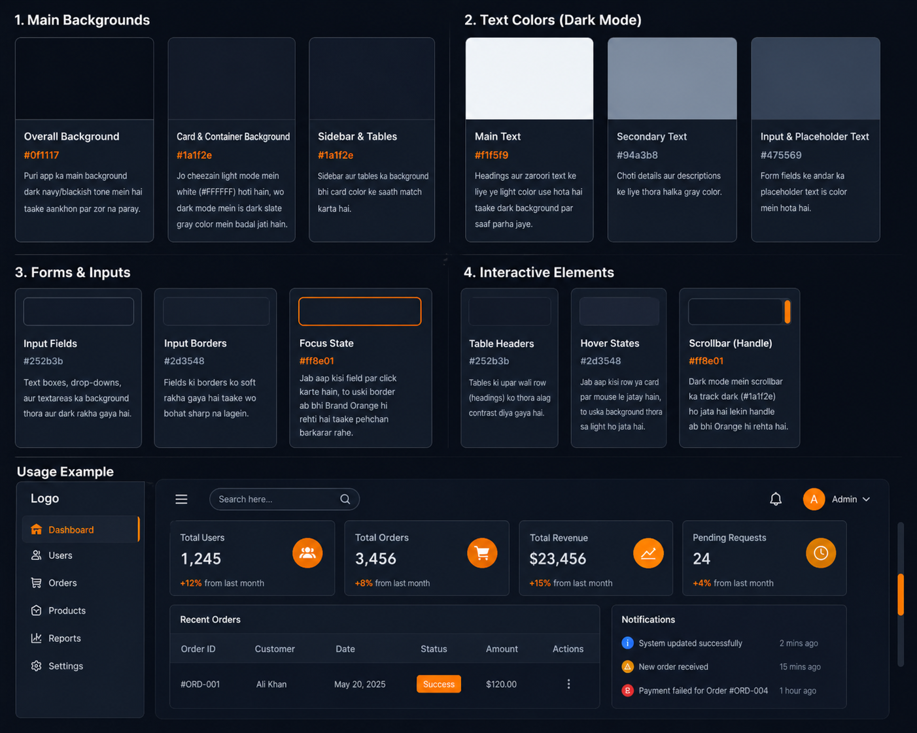
1. Main Backgrounds
- Overall Background (#0f1117 - Deep Dark): Puri app ka main background dark navy/blackish tone mein hai taake aankhon par zor na paray.
- Card & Container Background (#1a1f2e): Jo cheezain light mode mein white (#FFFFFF) hoti hain, wo dark mode mein is dark slate gray color mein badal jati hain.
- Sidebar & Tables (#1a1f2e): Sidebar aur tables ka background bhi card color ke saath match karta hai.
2. Text Colors (Dark Mode)
- Main Text (#f1f5f9 - Off White): Headings aur zaroori text ke liye ye light color use hota hai taake dark background par saaf parha jaye.
- Secondary Text (#94a3b8 - Muted Slate): Choti details aur descriptions ke liye thora halka gray color.
- Input & Placeholder Text (#475569): Form fields ke andar ka placeholder text is color mein hota hai.
3. Forms & Inputs
- Input Fields (#1E2435): Text boxes, drop-downs, aur textareas ka background thora aur dark rakha gaya hai.
- Input Borders (#2d3548): Fields ki borders ko soft rakha gaya hai taake wo bohat sharp na lagein.
- Focus State (#ff8e01): Jab aap kisi field par click karte hain, to uski border ab bhi Brand Orange hi rehti hai taake pehchan barkarar rahe.
4. Interactive Elements
- Table Headers (#252b3b): Tables ki upar wali row (headings) ko thora alag contrast diya gaya hai.
- Hover States (#2d3548): Jab aap kisi row ya card par mouse le jatay hain, to uska background thora sa light ho jata hai.
- Scrollbar: Dark mode mein scrollbar ka track dark (#1a1f2e) ho jata hai lekin handle ab bhi Orange hi rehta hai.
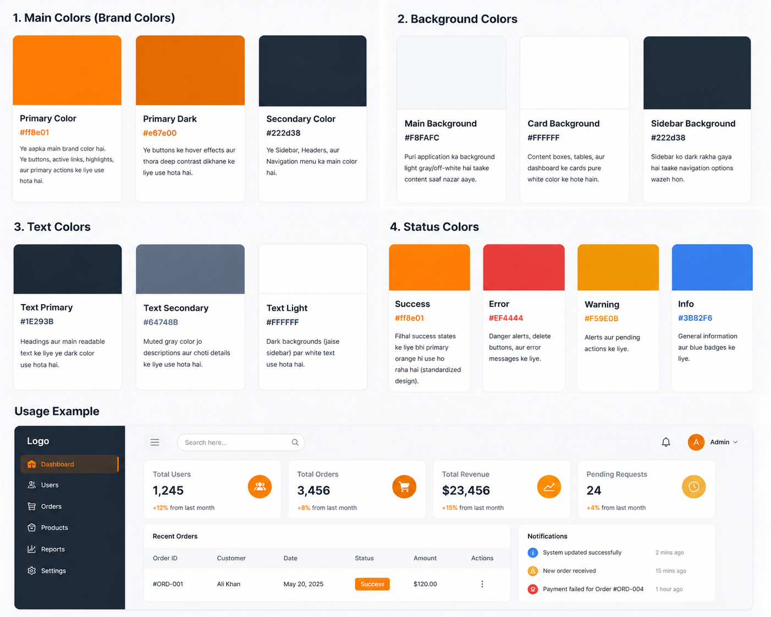
Theam 1
1. Main Colors (Brand Colors)
- Primary Color (#ff8e01 ): Ye aapka main brand color hai. Ye buttons, active links, highlights, aur primary actions ke liye use hota hai.
- Primary Dark (#e67e00): Ye buttons ke hover effects aur thora deep contrast dikhane ke liye use hota hai.
- Secondary Color (#222d38 ): Ye Sidebar, Headers, aur Navigation menu ka main color hai.
2. Background Colors
- Main Background (#F8FAFC): Puri application ka background light gray/off-white hai taake content saaf nazar aaye.
- Card Background (#FFFFFF): Content boxes, tables, aur dashboard ke cards pure white color ke hote hain.
- Sidebar Background (#222d38): Sidebar ko dark rakha gaya hai taake navigation options wazeh hon.
3. Text Colors
- Text Primary (#1E293B): Headings aur main readable text ke liye ye dark color use hota hai.
- Text Secondary (#64748B): Muted gray color jo descriptions aur choti details ke liye use hota hai.
- Text Light (#FFFFFF): Dark backgrounds (jaise sidebar) par white text use hota hai.
4. Status Colors
- Success (#ff8e01): Filhal success states ke liye bhi primary orange hi use ho raha hai (standardized design).
- Error (#EF4444 ): Danger alerts, delete buttons, aur error messages ke liye.
- Warning (#F59E0B ): Alerts aur pending actions ke liye.
- Info (#3B82F6 ): General information aur blue badges ke liye.

Theam 2
1. Main Colors (Brand Colors)
- Primary Color (#f5d7a5 ): Ye aapka main brand color hai. Ye buttons, active links, highlights, aur primary actions ke liye use hota hai.
- Primary Dark (#f5d7a5): Ye buttons ke hover effects aur thora deep contrast dikhane ke liye use hota hai.
- Secondary Color (#6b3d25 ): Ye Sidebar, Headers, aur Navigation menu ka main color hai.
2. Background Colors
- Main Background (#F8FAFC): Puri application ka background light gray/off-white hai taake content saaf nazar aaye.
- Card Background (#FFFFFF): Content boxes, tables, aur dashboard ke cards pure white color ke hote hain.
- Sidebar Background (#6b3d25): Sidebar ko dark rakha gaya hai taake navigation options wazeh hon.
3. Text Colors
- Text Primary (#65371d): Headings aur main readable text ke liye ye dark color use hota hai.
- Text Secondary (#f4e6d9): Muted gray color jo descriptions aur choti details ke liye use hota hai.
- Text Light (#FFFFFF): Dark backgrounds (jaise sidebar) par white text use hota hai.
4. Status Colors
- Success (#ff8e01): Filhal success states ke liye bhi primary orange hi use ho raha hai (standardized design).
- Error (#EF4444 ): Danger alerts, delete buttons, aur error messages ke liye.
- Warning (#F59E0B ): Alerts aur pending actions ke liye.
- Info (#3B82F6 ): General information aur blue badges ke liye.

Theam 3
1. Main Colors (Brand Colors)
- Primary Color (#678018): Ye aapka main brand color hai. Ye buttons, active links, highlights, aur primary actions ke liye use hota hai.
- Primary Dark (#678018): Ye buttons ke hover effects aur thora deep contrast dikhane ke liye use hota hai.
- Secondary Color (#324321): Ye Sidebar, Headers, aur Navigation menu ka main color hai.
2. Background Colors
- Main Background (#F8FAFC): Puri application ka background light gray/off-white hai taake content saaf nazar aaye.
- Card Background (#FFFFFF): Content boxes, tables, aur dashboard ke cards pure white color ke hote hain.
- Sidebar Background (#324321): Sidebar ko dark rakha gaya hai taake navigation options wazeh hon.
3. Text Colors
- Text Primary (#2f401e): Headings aur main readable text ke liye ye dark color use hota hai.
- Text Secondary (#ecf0d5): Muted gray color jo descriptions aur choti details ke liye use hota hai.
- Text Light (#FFFFFF): Dark backgrounds (jaise sidebar) par white text use hota hai.
4. Status Colors
- Success (#ff8e01): Filhal success states ke liye bhi primary orange hi use ho raha hai (standardized design).
- Error (#EF4444 ): Danger alerts, delete buttons, aur error messages ke liye.
- Warning (#F59E0B ): Alerts aur pending actions ke liye.
- Info (#3B82F6 ): General information aur blue badges ke liye.

Theam 4
1. Main Colors (Brand Colors)
- Primary Color (#1154bd): Ye aapka main brand color hai. Ye buttons, active links, highlights, aur primary actions ke liye use hota hai.
- Primary Dark (#1154bd): Ye buttons ke hover effects aur thora deep contrast dikhane ke liye use hota hai.
- Secondary Color (#0a316a): Ye Sidebar, Headers, aur Navigation menu ka main color hai.
2. Background Colors
- Main Background (#F8FAFC): Puri application ka background light gray/off-white hai taake content saaf nazar aaye.
- Card Background (#FFFFFF): Content boxes, tables, aur dashboard ke cards pure white color ke hote hain.
- Sidebar Background (#0a316a): Sidebar ko dark rakha gaya hai taake navigation options wazeh hon.
3. Text Colors
- Text Primary (#0b2c5f): Headings aur main readable text ke liye ye dark color use hota hai.
- Text Secondary (#ecf0d5): Muted gray color jo descriptions aur choti details ke liye use hota hai.
- Text Light (#FFFFFF): Dark backgrounds (jaise sidebar) par white text use hota hai.
4. Status Colors
- Success (#ff8e01): Filhal success states ke liye bhi primary orange hi use ho raha hai (standardized design).
- Error (#EF4444 ): Danger alerts, delete buttons, aur error messages ke liye.
- Warning (#F59E0B ): Alerts aur pending actions ke liye.
- Info (#3B82F6 ): General information aur blue badges ke liye.

Theam 5
1. Main Colors (Brand Colors)
- Primary Color (#fedef6): Ye aapka main brand color hai. Ye buttons, active links, highlights, aur primary actions ke liye use hota hai.
- Primary Dark (#fedef6): Ye buttons ke hover effects aur thora deep contrast dikhane ke liye use hota hai.
- Secondary Color (#6841c2): Ye Sidebar, Headers, aur Navigation menu ka main color hai.
2. Background Colors
- Main Background (#F8FAFC): Puri application ka background light gray/off-white hai taake content saaf nazar aaye.
- Card Background (#FFFFFF): Content boxes, tables, aur dashboard ke cards pure white color ke hote hain.
- Sidebar Background (#6841c2): Sidebar ko dark rakha gaya hai taake navigation options wazeh hon.
3. Text Colors
- Text Primary (#4e2bab): Headings aur main readable text ke liye ye dark color use hota hai.
- Text Secondary (#9b84ec): Muted gray color jo descriptions aur choti details ke liye use hota hai.
- Text Light (#FFFFFF): Dark backgrounds (jaise sidebar) par white text use hota hai.
4. Status Colors
- Success (#ff8e01): Filhal success states ke liye bhi primary orange hi use ho raha hai (standardized design).
- Error (#EF4444 ): Danger alerts, delete buttons, aur error messages ke liye.
- Warning (#F59E0B ): Alerts aur pending actions ke liye.
- Info (#3B82F6 ): General information aur blue badges ke liye.

Theam 6
1. Main Colors (Brand Colors)
- Primary Color (#f83c93): Ye aapka main brand color hai. Ye buttons, active links, highlights, aur primary actions ke liye use hota hai.
- Primary Dark (#f83c93): Ye buttons ke hover effects aur thora deep contrast dikhane ke liye use hota hai.
- Secondary Color (#b11954): Ye Sidebar, Headers, aur Navigation menu ka main color hai.
2. Background Colors
- Main Background (#F8FAFC): Puri application ka background light gray/off-white hai taake content saaf nazar aaye.
- Card Background (#FFFFFF): Content boxes, tables, aur dashboard ke cards pure white color ke hote hain.
- Sidebar Background (#b11954): Sidebar ko dark rakha gaya hai taake navigation options wazeh hon.
3. Text Colors
- Text Primary (#920d3e): Headings aur main readable text ke liye ye dark color use hota hai.
- Text Secondary (#f83c93): Muted gray color jo descriptions aur choti details ke liye use hota hai.
- Text Light (#FFFFFF): Dark backgrounds (jaise sidebar) par white text use hota hai.
4. Status Colors
- Success (#ff8e01): Filhal success states ke liye bhi primary orange hi use ho raha hai (standardized design).
- Error (#EF4444 ): Danger alerts, delete buttons, aur error messages ke liye.
- Warning (#F59E0B ): Alerts aur pending actions ke liye.
- Info (#3B82F6 ): General information aur blue badges ke liye.

